Db structure

DB Name: UnitData

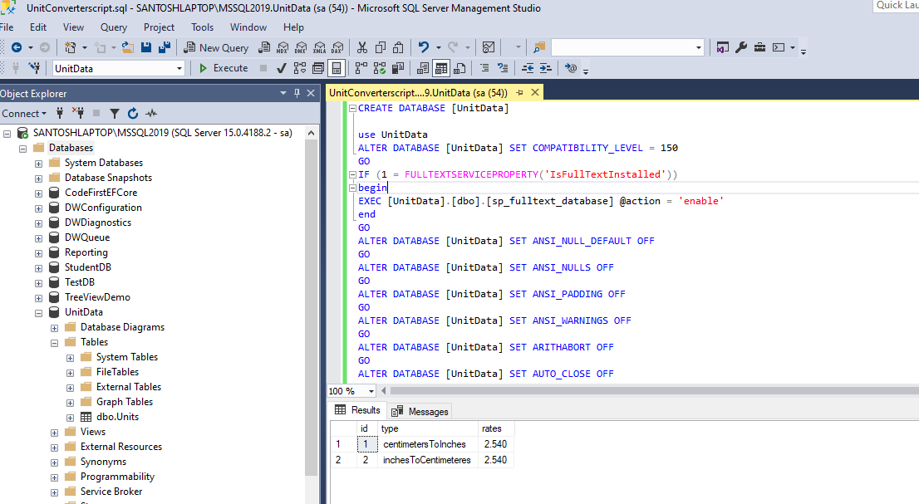

Project (API Structure)

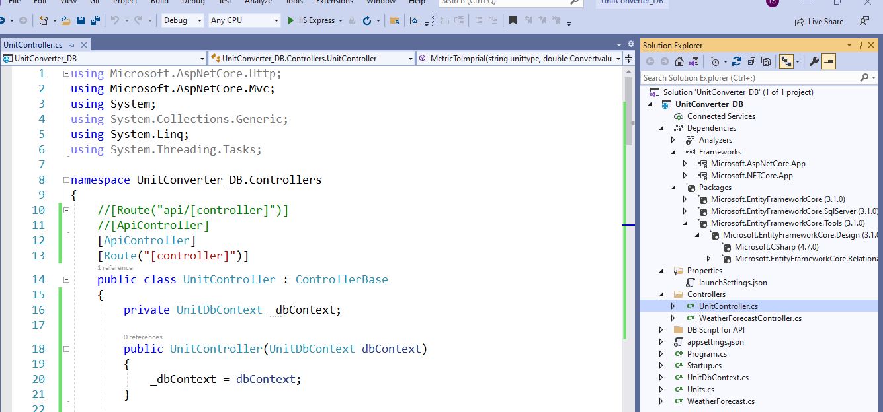

Output URL:

https://localhost:44335/unit/**MetricToImprial**/centimetersToInches/25

https://localhost:44335/unit/**ImprialToMetric**/inchesToCentimeteres/9.84251968503937